
United International University
Department of CSE
Course Code: CSE 4326
Course Name: Microprocessors & Microcontrollers Laboratory
Experiment no: 1(b)
Experiment Name: An introduction to Arduino, Interfacing of Gas Sensor using Arduino & Showing the Sensor Data in OLED Display
Submitted by:
Name: Naznin Sultana Tonni(On Behalf of My Team)
Student ID’s:
- Naznin Sultana Tonni(0112330125)
- Raunak Binte Islam Faiza(0112330953)
- Talha Jubayer(0112410062)
- Rokan Uddin(0112330735)
- Atiqur Rahman Atiq(0112330317)
- Fatema Tuz Zohura Rifa(0112330722)
Section: E
Date of Submission:03/10/2026
Objective:

The objective of this experiment is to interface an MQ-2 gas sensor with an Arduino microcontroller to detect combustible/harmful gas concentrations, display the readings and status messages on an OLED screen, and trigger safety responses like a buzzer alarm or motorized exhaust fan when gas levels exceed a safe threshold

Apparatus / Instruments Used in the Lab
- Arduino Uno board (Arduino Uno model)
- MQ-2 Gas Sensor
- OLED Display
- Buzzer
- DC motor (representing the exhaust fan)
- Resistors
- Breadboard and jumper wires
- Computer/Laptop with Arduino IDE
Theory:
MQ-2 Gas Sensor: This is a metal oxide sensor that can detect gases like Methane, CO, Smoke, and Hydrogen. When it senses gas, its conductivity changes, and this change is turned into a signal (analog or digital) representing the gas concentration in parts per million (ppm).
OLED Display: A small, low-power screen used to show live sensor readings. It usually connects to the microcontroller using the I2C communication protocol.
Buzzer: A simple component that makes sound to act as an alarm. It turns on when the microcontroller sends it a digital HIGH signal.
System Logic: The microcontroller keeps reading data from the MQ-2 sensor. If the ppm value crosses the set threshold, it displays a warning message on the OLED and turns on both the buzzer respond to the gas leak.

Solution of the mentioned problems:
Task 1: Display Gas Sensor Data on OLED
The MQ-2 sensor's output was wired to an analog pin on the microcontroller. The program reads this analog value, converts it into an approximate ppm reading, and shows it on the I2C OLED screen as "Gas sensor data: ppm value." (Figure 1)
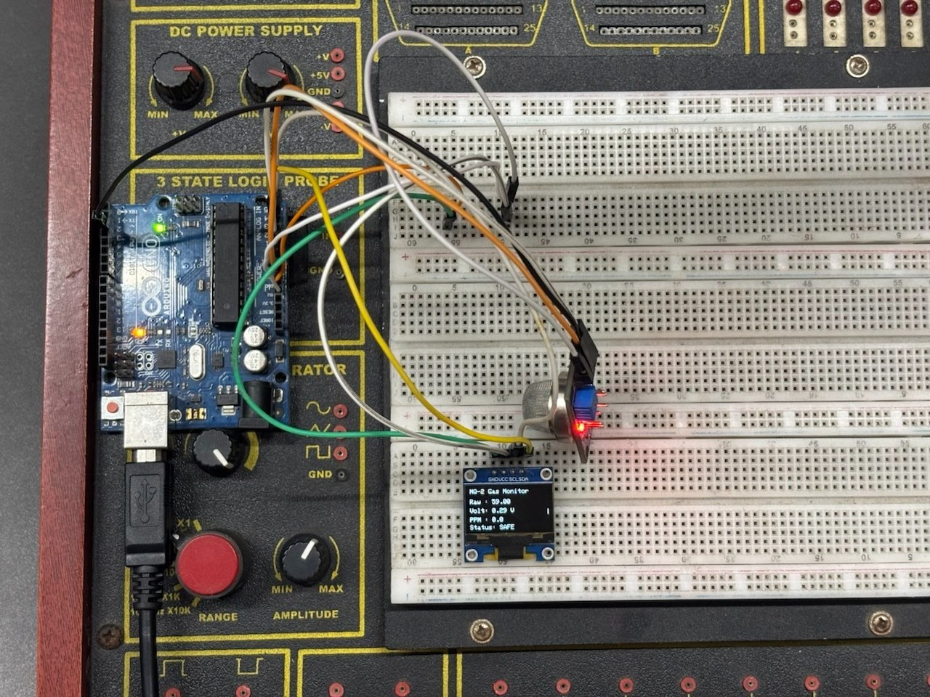
Figure 1: OLED display showing the live gas sensor reading.
Task 2: Turn On a Buzzer/Alarm Above a Threshold
A threshold value was defined in the code. Whenever the sensor's ppm reading crosses this limit, the digital pin connected to the buzzer is set HIGH, sounding an alarm to give an instant warning. (Figure 2)
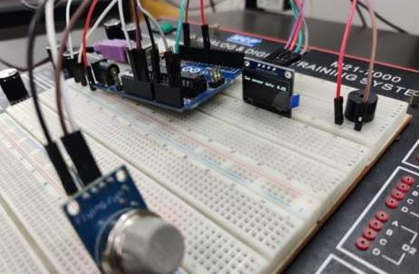
Figure 2:Buzzer/alarm status once gas is detected.
Task 3: Show "Gas is Detected" on OLED
Using the same threshold check as Task 2, the moment gas concentration exceeds the limit, the OLED simultaneously displays the message "Gas is detected" alongside the ppm reading. (Figure 3)
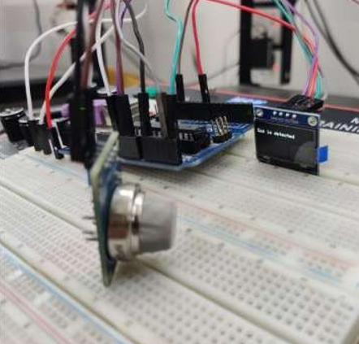
Figure 3:OLED screen showing the "Gas is detected" warning message.
Program codes:
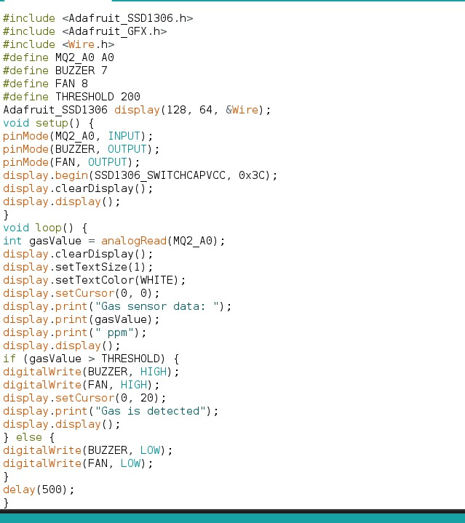

Discussion:
The gas sensing system worked successfully detecting the presence of gas and automatically carrying out the necessary safety responses.The MQ-2 sensor continuously monitors the surrounding air, and as soon as its reading crosses the defined threshold, the system reacts on multiple fronts at once like it sounds the buzzer to alert anyone nearby,switches on the exhaust fan to start clearing the hazardous fumes and simultaneously displays a clear warning message on the OLED screen so the situation can be identified as soon as possible.

